**永达（香港）实业有限公司**

**海南元贞实业有限公司**

**在全国建立3000家分公司**

**在世界各国建立以国内分公司**

**合作合资一对一分公司3000个共计6000个分公司：商业计划书（大纲）**

**Yongda (Hong Kong) Industrial Co., Ltd**

**Hainan Yuanzhen Industrial Co., Ltd**

**Establish 3000 branches across the country**

**Establish domestic branches all over the world**

**3000 one-to-one branches of cooperative joint venture, with a total of 6000 branches: business plan (outline)**

**前言**

**preface**

**永达（香港）实业有限公司成立于2014年7月，是一家多元化、现代化、国际化的综合性实业公司。我公司秉承以国家利益高于一切、诚信守法、客户至上、质量为本的原则，立足新起点，开创新局面。努力开展经营活动。**

**Yongda(hongkong) Industrial Co., Ltd. was established in June 2006 with a registered capital of 100 million yuan. It is a diversified, modern and international comprehensive industrial company. Our company adheres to the principles of putting national interests above everything, integrity and law-abiding, customer first and quality-oriented, based on a new starting point and creating a new situation. Strive to carry out business activities.**

**公司成立以来，我们转变观念，改进作风，创新机制。本着团结、开拓、务实、求精的精神，积极拓展业务范围，收到了可喜的成果。业务范围包括：贵重金属现货交易（开展会员制），原油，燃料油，成品油，天然气，石油化工产品，冶金矿产资源，燃料能源，机械机电，医药卫生，建筑建材，电子产品，国内国际工程承发包，土石方运输，建筑我，装潢装修工程，水处理工程，进出口贸易，房屋租赁代理销售，农产品，资产管理，食品等业务。我公司将凭科技开拓市场，凭管理增创效益，凭服务树立形象。**

**Since the establishment of the company, we have changed our ideas, improved our style and innovated the mechanism. In the spirit of unity, development, pragmatism and refinement, we have actively expanded our business scope and achieved gratifying results. The business scope includes: spot trading of precious metals (carrying out membership system), crude oil, fuel oil, refined oil, natural gas, petrochemical products, metallurgical and mineral resources, fuel energy, machinery, electromechanical, medicine and health, building materials, electronic products, domestic and international engineering contracting package, earthwork transportation, construction, decoration engineering, water treatment engineering, import and export trade, House leasing, agent sales, agricultural products, asset management, food and other businesses. Our company will develop the market by science and technology, create benefits by management and establish an image by service.**

**永达（香港）实业有限公司成立至今，以国家经济发展为宗旨，积极同海内外企业和各界人士发展业务联系，并跻身同行业的领先地位，在海内外逐步形成一定影响。这些年通过我公司全体人员的奋斗和努力，凭借雄厚的财经实力以及有国内外强大经济实力公司合作的基础，以及我公司发展远景的规划需要，愿积极拓展海外事业，面向国内，国际寻求有相当经济实力的专业性公司合作，与我公司建立和发展战略合作伙伴关系，成立互补性商务合作分公司，针对国际商品的采购销售信息，建立真实、专业、及时的互通传递机制。**

**Since its establishment, Yongda(hongkong) Industrial Co., Ltd., with the purpose of national economic development, has actively developed business contacts with enterprises and people from all walks of life at home and abroad, ranked among the leading positions in the same industry, and gradually formed a certain influence at home and abroad. In recent years, through the struggle and efforts of all staff of our company, relying on our strong financial strength, the basis of cooperation with companies with strong economic strength at home and abroad, and the planning needs of our development vision, we are willing to actively expand overseas undertakings, seek domestic and international professional companies with considerable economic strength, and establish and develop strategic partnership with our company, Establish complementary business cooperation branches to establish a real, professional and timely communication and transmission mechanism for the procurement and sales information of international commodities.**

**在国内每个省、直辖市、自治区及地区市、县寻求合作公司，采取项目采购、销售合作方式，成立多家海南元贞实业有限分公司，建立有效畅通的业务信息联络机制，并确保将国际国内、各合作子公司，分公司所供求的各种产品信息，及时汇总，发布、传递给大家，商品商务交叉协助交易。**

**Seek cooperative companies in each province, municipality directly under the central government, autonomous region, regional city and county in China, adopt the mode of project procurement and sales cooperation, establish multiple Yongda(hongkong) Industrial Co., Ltd., establish an effective and smooth business information contact mechanism, and ensure that all kinds of product information supplied and supplied by international and domestic cooperative subsidiaries and branches are timely summarized, released and transmitted to everyone, Commodity business cross transaction assistance.**

**目录**

**catalogue**

**第一章**

**Chapter I**

**计划概要**

**summary schedule**

**第二章**

**Chapter II**

**项目介绍**

**Project introduction**

**第三章**

**Chapter III**

**行业分析**

**Industry analysis**

**第四章**

**Chapter IV**

**商业模式**

**business model**

**第五章**

**Chapter V**

**运营管理**

**operation management**

**以上为基础大纲，后续还需要完善......**

**The above is the basic outline, which needs to be improved in the future......**

1. **计划概要**

**Chapter I plan outline**

1. **计划概要**

**一、 Plan summary**

**发展国际国内的专业子公司，分公司的合作，是我公司今年重点开展的工作。为了适应当前国内外采购销售市场的需要，我公司董事会决定，向全球投资，参股加盟，联盟，三千个分公司，全国寻求投资，参股加盟，联盟三千个分公司，一些专业公司，个体经营者，作为我公司在该地区的合作分子公司，公司的代表，原则每个区，县限定一家子公司或者分公司，多个个体经营者根据实际情况决定。**

**The development of cooperation between international and domestic professional subsidiaries and branches is the focus of our company this year. In order to meet the needs of the current procurement and sales market at home and abroad, the board of directors of our company has decided to invest globally, participate in and join the alliance, 3000 branches, seek investment, participate in and join the alliance, 3000 branches, some professional companies and self-employed operators. As the cooperative subsidiary companies and representatives of the company in the region, in principle, each district, The county limits one subsidiary or branch, and multiple self-employed operators shall be determined according to the actual situation.**

**合作原则与条件：**

**1.有一定人脉关系经济实力的专业化公司，多个个体经营者；**

**2.诚信为本，求真务实；**

**3.利益共享，风险共担；**

**4.合作公司的股份60%由总公司持有，4 0%由当地合作公司持有。**

**5.签订合作合同书及保密协议。**

**Principles and conditions of cooperation:**

**1. Professional companies with certain contacts and economic strength, multiple self-employed;**

**2. Honesty, truth-seeking and pragmatic;**

**3. Benefit sharing and risk sharing;**

**4. 60% of the shares of the cooperative company are held by the head office and 40% by the local cooperative company.**

**5. Sign cooperation contract and confidentiality agreement.**

**欢迎有意加盟永达（香港）实业有限公司，子公司或者分公司，个体经营者团队、人才，毛遂自荐，协商合作。子公司，分公司，个体经营者全体人员享有总公司的经营交易的权限，同时也必须按照本公司发展章程规定办事。**

**Welcome to join Yongda(hongkong) Industrial Co., Ltd., subsidiaries or branches, self-employed teams and talents, introduce themselves, negotiate and cooperate. All personnel of subsidiaries, branches and self-employed operators shall enjoy the authority of the head office to operate transactions, and must also act in accordance with the provisions of the development articles of association of the company.**

**另外，永达（香港）实业有限公司筹备在国内外建立基础设施投资、必须操作的贵金属现货柜台交易、这是安置就业岗位重要的项目，正式实施出具经营方案。**

**In addition, Yongda(hongkong) Industrial Co., Ltd. is preparing to establish infrastructure investment at home and abroad and must operate precious metal spot over-the-counter trading, which is an important project for job placement, and formally implement the business plan.**

**第二章 项目介绍**

**Chapter II project introduction**

**项目将分为四大项：钢铁板块、石油化工板块、金融板块、农业“农光互补”板块等。**

**The project will be divided into four major items: steel plate, petrochemical plate, financial plate, agricultural "agricultural light complementary" plate, etc.**

**一、钢铁板块**

**一、 Steel plate**

**1.进口产品：回收再生资源废旧钢铁 、铁精粉等**

**1. Imported products: recycled resources, waste iron and steel, iron concentrate powder, etc**

**1.1.在全球范围内通过投资、并购重组、加盟、自营等多种方式建立一整套完整的废旧金属、有色金属、铁晶粉回收拆解及出口、进口销售的渠道。**

**1.1. Establish a complete set of channels for recycling, dismantling, export, import and sales of waste metals, non-ferrous metals and iron crystal powder through investment, M &amp; A, franchise, self operation and other means all over the world.**

**1.2在全球范围内建立五大区，分别为大东亚区，中东区，北美区，南美区，欧洲区由各大区统一管理各区所属地的一切事物，按时按质完成总部下达的一切指标。**

**1.2 establish five regions around the world, namely Greater East Asia, the Middle East, North America, South America and Europe. All things belonging to each region shall be uniformly managed by each region, and all indicators issued by the headquarters shall be completed on time and quality.**

**1.3公司全运营后，计划年回收量达到废旧钢铁3亿吨左右，年毛利3000亿人民币左右。铁精粉年回收量达到5亿吨左右，年毛利润3000亿元人民币，有色金属年回收1000万吨左右内毛利润3000亿元。铅锌矿、铜矿、有色金属矿业、开采深加工年毛利润5000亿元人民币吧。**

**1.3 after the full operation of the company, the annual recycling volume is planned to reach about 300 million tons of waste steel, with an annual gross profit of about 300 billion yuan. The annual recovery of iron concentrate powder reaches about 500 million tons, with an annual gross profit of 300 billion yuan, and the annual recovery of non-ferrous metals is about 10 million tons, with an internal gross profit of 300 billion yuan. The annual gross profit of lead-zinc, copper, nonferrous metal mining and deep processing is 500 billion yuan.**

**2.大型拆船厂**

**2. Large ship dismantling plant**

**2.1计划在中东国家收购或入股大型拆船厂，拆船的工序首先由燃料开始，所有船内的柴油、机油、还有任何燃料都会被先抽取出来转售。然后就是其他船身上的配件如引擎、电池、发电机等等都会被一一拆除转售，或者再拆解为原材料并运用在其他地方。最后，工人会用烧焊工具把空荡荡的船架再拆解和熔解成金属原材料，各种零件都毫不浪费，年毛利润5000亿元人民币。**

**2.1 it is planned to acquire or take shares in large ship dismantling plants in Middle East countries. The ship dismantling process starts with fuel, and all diesel, engine oil and any fuel in the ship will be extracted first for resale. Then, other ship accessories, such as engines, batteries, generators, etc., will be dismantled and resold one by one, or disassembled into raw materials and used in other places. Finally, workers will use welding tools to disassemble and fuse the empty ship frame into metal raw materials. All kinds of parts are not wasted, and the annual gross profit is 500 billion yuan.**

1. **Ф5500×8500超大型铁矿石球磨机**

**3.three Ф five thousand and five hundred × 8500 super large iron ore ball mill**

**3.1时产500吨的铁矿石球磨机。投资1万套。每套10万元人民币，租赁给每个分公司世界各地分公司生产加工铁精粉，以少基多，年产规模。**

**3.1 iron ore ball mill with an hourly output of 500 tons. Invest 10000 sets. Each set of 100000 yuan is leased to each branch. Branches all over the world produce and process iron concentrate powder, with an annual output of more than 100 million yuan.**

**二、石油化工板块**

**二、 Petrochemical sector**

**1.进口LNG天然气和LPG石油液化可移动撬装设备的租赁销售业务。**

**1. Leasing and sales of imported LNG natural gas and LPG liquefied petroleum movable skid mounted equipment.**

**目前，我公司准备投入单个储量四十吨的移动撬装设备30万个，装运1200个40吨气罐5万吨船20条，装运2500个40吨气罐10万吨船15条，装运5000个气罐20万吨船10条，在海外建立300万吨以上液化气厂10个，海上100万吨移动液化气厂20个，在中国进海域内建立天然气移动10万吨应急储备中心3个，技术质量是世界上最好的。汽车加气站和租赁销售项目总投资5000亿元人民币。项目完成后，可向全国及外国使用LNG天然气和LPG石油液化气的地区，提供优质的租赁销售服务。在此也寻求国内外有专业技术及一定的经济实力的公司和人员建立合作，年毛利润10000亿元人民币。**

**At present, our company plans to invest 300000 mobile skid mounted equipment with a single reserve of 40 tons, 20 50000 ton ships carrying 1200 40 ton gas tanks, 15 100000 ton ships carrying 2500 40 ton gas tanks, 10 200000 ton ships carrying 5000 gas tanks, 10 liquefied gas plants with a capacity of more than 3 million tons overseas and 20 mobile liquefied gas plants with a capacity of 1 million tons offshore, Three 100000 ton emergency reserve centers for mobile natural gas have been established in China's sea area, with the best technical quality in the world. The total investment of automobile filling stations and leasing sales projects is 500 billion yuan. After the completion of the project, it can provide high-quality leasing and sales services to national and foreign regions using LNG and LPG liquefied petroleum gas. We also seek to establish cooperation with companies and personnel with professional technology and certain economic strength at home and abroad, with an annual gross profit of RMB 100 billion.**

1. **海上垃圾无人处理平台成套设备租赁销售。**

**2. Leasing and sales of complete sets of equipment for marine garbage unmanned treatment platform.**

**距离陆地最近的公海设立海上垃圾处理中心，会员制模式经营。可减少陆地现在所面临的垃圾带来的污染问题，年毛利润10000亿元人民币。**

**The high seas closest to the land shall set up marine waste treatment centers, which shall be operated in the membership mode. It can reduce the pollution caused by garbage on land, with an annual gross profit of RMB 100 billion.**

1. **水陆联运20尺、40尺铝制品集装箱各500万个租赁销售。**

**3. 5 million aluminum product containers of 20 feet and 40 feet through water and land transportation are leased and sold respectively.**

**4.60万辆车水果蔬菜鲜花恒温保鲜集装箱，保鲜生产冷链物流基地，年毛利润3000亿元人民币。**

**4.6000 cars of constant temperature fresh-keeping containers for fruits, vegetables and flowers, cold chain logistics base for fresh-keeping production, with an annual gross profit of 300 billion yuan.**

**三、金融板块**

**三、 Financial sector**

**1. 贵金属柜台**

**1. Precious metal counter**

**针对金融产品板块创新衍生出新的理财产品，前期金融产品的发行将于分公司的员工来完成销售。打造等同于市面上黄金、珠宝等形式的流通的金融产品。相对的，分公司的人员配置都将采用残疾人的用工形式，提供工作岗位的同时，我们更看中国家对残疾人创业资金的扶持。届时，每个分公司的员工都将认购公司的股份，公司从而提供等价的价值体系，年毛利润20000万亿元人民币。**

**New financial products are derived from the innovation of financial products, and the early issuance of financial products will be completed by the employees of the branch. Create financial products equivalent to the circulation of gold, jewelry and other forms on the market. In contrast, the staffing of the branches will adopt the employment form of the disabled. While providing jobs, we also look at China's support for the entrepreneurial funds of the disabled. At that time, the employees of each branch will subscribe for the shares of the company, so as to provide the company with an equivalent value system, with an annual gross profit of RMB 20000 trillion.**

1. **农业板块**

**四、 Agricultural sector**

**1.“农光互补”光伏发电**

**1. "Agriculture light complementary" photovoltaic power generation**

**1.1光伏发电与现代农业大棚相结合的大型并网发电项目，其模式采用:**

**1.1 the mode of large-scale grid connected power generation project combining photovoltaic power generation with modern agricultural greenhouse is as follows:**

**①、地面池塘单棚模式:**

**直接在非农耕地的滩涂、路边、池塘、江边、荒山草地等安装晶体硅光伏电池组件， 组成地面电站发电。**

**① . single shed mode of ground pond:**

**Crystalline silicon photovoltaic cell modules are directly installed on beaches, roadsides, ponds, riversides, barren mountains and grasslands of non-agricultural cultivated land to form a ground power station for power generation.**

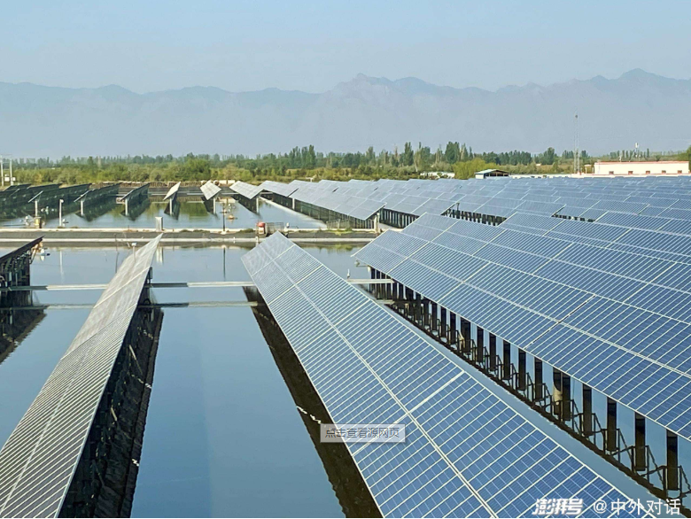

**②“一棚二用”模式**

**② "One shed and two uses" mode**

**1.棚顶安装晶体硅光伏电池组件，利用光伏发电板接受太阳能量进行发电:**

**1. Crystalline silicon photovoltaic cell modules are installed on the roof, and photovoltaic power generation panels are used to receive solar energy for power generation:**

**2棚内农业种植,种植红托竹荪蔬菜、食用菌蓝莓水果等,实现了光伏农业大棚体化"管理。**

**2. Agricultural planting in the shed, including red tuozhusun vegetables, edible fungi, blueberries and fruits, has realized the "integrated" management of photovoltaic agricultural shed.**

**③、“一棚三用”模式**

**③ "One shed and three uses" mode**

**1棚顶安装晶体硅光伏电池组件，利用光伏发电板接受太阳能量进行发电:**

**1. Crystalline silicon photovoltaic cell modules are installed on the roof, and photovoltaic power generation panels are used to receive solar energy for power generation:**

1. **棚下(低洼闲置池塘)进行水产养殖，鱼虾成群;**

**2. Aquaculture under the shed (low-lying idle pond), with fish and shrimp in groups;**

**3.棚中提供大型水产批发交易市场、商贸中心水产研发中心;年毛利润5000亿元人民币。**

**3. Provide large-scale aquatic products wholesale trading market, trade center and aquatic products R &amp; D center in the shed; The annual gross profit is 500 billion yuan.**

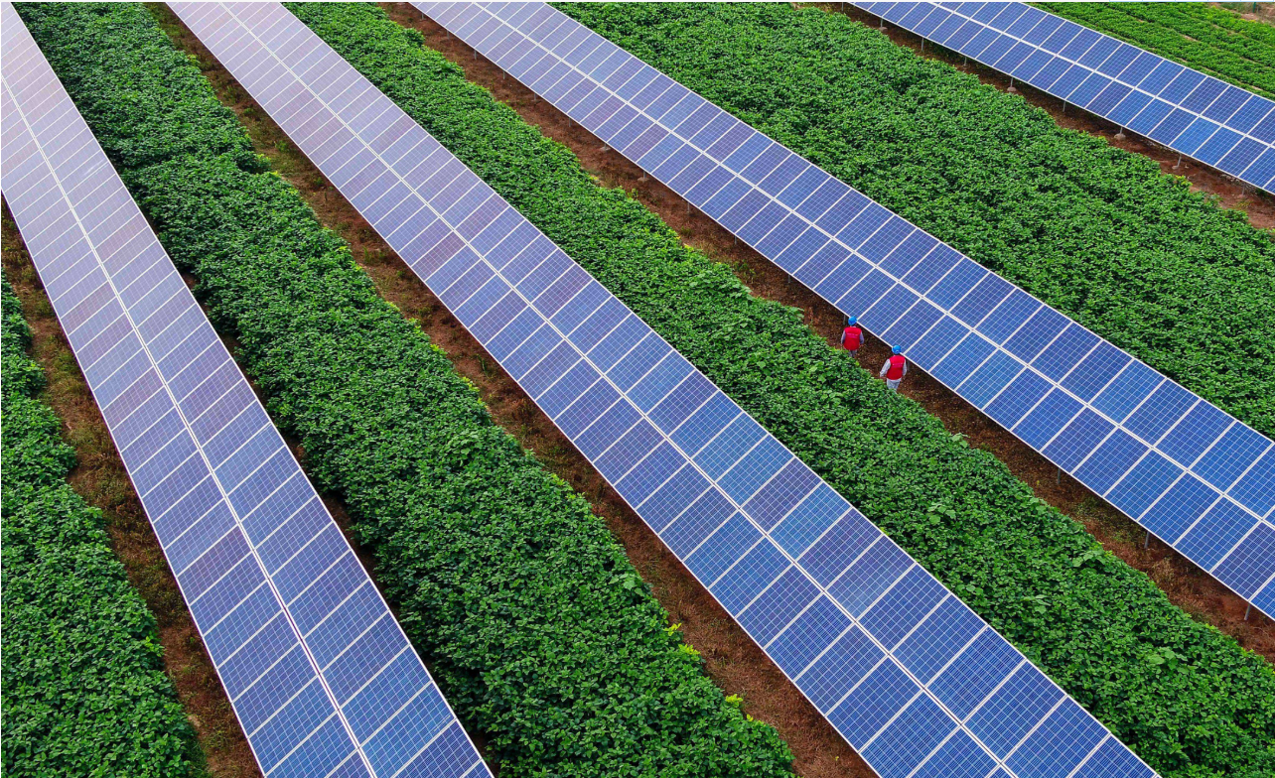**第三章 行业分析**

**Chapter III industry analysis**

1. **钢铁板块**

**一、 Steel plate**

**1.废旧钢铁回收**

**1. Waste steel recycling**

**近年来中国粗钢产量、生铁产量及废钢铁回收量均持续增长，2018年中国粗钢产量为92904万吨，较2017年增长了5830万吨；2019年中国粗钢产量为99634万吨，较2018年增长了6730万吨。2018年中国生铁产量为77988万吨，较2017年增长了6626万吨；2019年中国生铁产量为80937万吨，较2018年增长了2949万吨。2017年中国废钢铁回收量为17391万吨，较2016年增长了2261万吨；2018年中国废钢铁回收量为21277万吨，较2017年增长了3886万吨。**

**In recent years, China's crude steel output, pig iron output and waste steel recovery have continued to grow. In 2018, China's crude steel output was 929.04 million tons, an increase of 58.3 million tons over 2017; In 2019, China's crude steel output was 996.34 million tons, an increase of 67.3 million tons over 2018. In 2018, China's pig iron output was 779.88 million tons, an increase of 66.26 million tons over 2017; In 2019, China's pig iron output was 809.37 million tons, an increase of 29.49 million tons over 2018. In 2017, China's waste steel recycling volume was 173.91 million tons, an increase of 22.61 million tons over 2016; In 2018, China's waste steel recycling volume was 212.77 million tons, an increase of 38.86 million tons compared with 2017.**

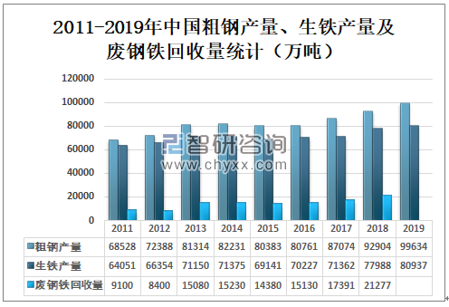

**废钢铁利用量迅速提高，中国废钢回收量占粗钢产量、生铁产量比例均持续增长，2017年中国废钢回收量占粗钢产量的19.97%，较2016年增长了1.24%；2018年中国废钢回收量占粗钢产量的22.90%，较2017年增长了2.93%。2017年中国废钢回收量占生铁产量的24.37%，较2016年增加了2.83%；2018年中国废钢回收量占生铁产量的27.28%，较2017年增加了2.91%。**

**The consumption of scrap iron increased rapidly. The proportion of scrap steel recovery in crude steel output and pig iron output in China continued to grow. In 2017, China's scrap steel recovery accounted for 19.97% of crude steel output, an increase of 1.24% over 2016; In 2018, China's scrap recovery accounted for 22.90% of crude steel output, an increase of 2.93% over 2017. In 2017, China's scrap recovery accounted for 24.37% of pig iron production, an increase of 2.83% over 2016; In 2018, China's scrap recovery accounted for 27.28% of pig iron production, an increase of 2.91% over 2017.**

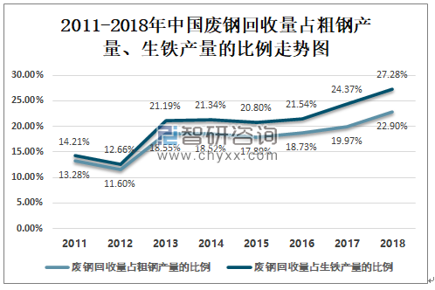

**2.大型拆船厂**

**2.Large ship dismantling plant**

**船舶在建造当初，为了能承受地球上最恶劣的环境，往往以有毒的材料建造，例如石绵和铅。如果在发达国家进行船只拆解，需要非常严格的监管，成本高不说，往往处理过程还很长。**

**When ships were built, in order to withstand the worst environment on earth, they were often built of toxic materials, such as asbestos and lead. If ship dismantling is carried out in developed countries, it needs very strict supervision, the cost is high, and the processing process is often very long.**

**因此，全世界的船只拆解工作大多在孟加拉、印度、印尼、巴基斯坦等发展中国家进行，这些地方劳动力较为便宜，而且几乎没有规范。印度的阿朗是世界上最大的拆船港。这里几乎所有的劳工都是来自印度北部的移民。2009年至今，他们拆了超过2600艘船。**

**Therefore, most of the ship dismantling work in the world is carried out in developing countries such as Bangladesh, India, Indonesia and Pakistan, where the labor force is relatively cheap and there is almost no standard. Aran in India is the largest ship dismantling port in the world. Almost all the workers here are immigrants from northern India. Since 2009, they have dismantled more than 2600 ships.**

**2020年三季度,全球共有170艘船舶被拆解,其中65%(约110艘)船是在南亚海滩被拆解的。南亚国家印度阿朗港、孟加拉国吉大港和巴基斯坦加达尼均是拆船工业国家中的一员，占全球拆船的80%。**

**In the third quarter of 2020, 170 ships were dismantled worldwide, of which 65% (about 110) were dismantled on the beaches of South Asia. South Asian countries, including port Arang of India, Chittagong of Bangladesh and gadani of Pakistan, are among the Shipbreaking industrial countries, accounting for 80% of the world's Shipbreaking.**

**孟加拉拆船厂业的丰厚利润，都是回收每艘船90%以上的材料所换来的。船厂会先由交易老旧船只的国际中介手中购得一艘报废船，在船只开到厂区停放后，先抽出船身中的残油、有毒烂泥等化学废物，再拆掉舱壁，紧接着就是开始回收的时间了。船上的每一个部分，包含缆索、钢材、发电机、烟囱、推进器救生艇、舱梯、水槽、厕所，甚至是灯泡等各式各样的机械零件，都会被拆船工人无所不用其极地卸下回收，转售给废料交易商。在船被拆到只剩下钢制船壳以后，这群来自孟加拉最贫困地区的工人，便会用乙炔炬把残余的船身切割成片，再将它们烧熔并轧制成建筑用的钢筋。**

**The huge profits of Bangladesh Shipbreaking industry are obtained by recycling more than 90% of the materials of each ship. The shipyard will first buy a scrapped ship from the international intermediary trading old ships. After the ship arrives at the factory for parking, it will first take out the residual oil, toxic sludge and other chemical wastes in the ship body, and then dismantle the bulkhead. Then it is time to start recycling. Every part of the ship, including cables, steel, generators, chimneys, thrusters, lifeboats, cabin ladders, sinks, toilets, and even light bulbs, will be unloaded and recycled by ship dismantling workers and resold to waste dealers. After the ship was torn down to a steel hull, this group of workers from the poorest areas of Bangladesh would use an acetylene torch to cut the remaining hull into pieces, burn them and roll them into building steel bars.**

1. **石油化工板块**

**二、Petrochemical sector**

1. **进口LNG天然气和LPG石油液化可移动撬装设备。**

**1. Imported LNG natural gas and LPG petroleum liquefaction movable skid mounted equipment.**

**近期，由国家能源局石油天然气司、国务院发展研究中心资源与环境政策研究所、自然资源部油气资源战略研究中心共同编写的《中国天然气发展报告2020》发布。报告就天然气行业的国内外生产与消费情况，以及相关数据做出了详尽报告，同时也对中国未来的天然气市场做出了发展前景预测。报告一经发布，便受到了行业的广泛关注和热烈讨论。有业内人士认为，撬装天然气液化设备或将有良好的发展前景。**

**Recently, the "China natural gas development report 2020" jointly prepared by the oil and gas Department of the national energy administration, the Institute of resources and environmental policy of the development research center of the State Council and the oil and gas resources strategy research center of the Ministry of natural resources was released. The report makes a detailed report on the domestic and foreign production and consumption of the natural gas industry and relevant data, and also forecasts the development prospect of China's future natural gas market. Once the report was released, it received extensive attention and heated discussion from the industry. Insiders believe that skid mounted natural gas liquefaction equipment may have good development prospects.**

**报告的第一部分，介绍了国际天然气市场的发展情况。总体来看，世界范围内的天然气产出地区主要集中在美洲和中亚地区。北美、中东、俄罗斯-中亚三个地区的总天然气产量占全球总产量的67%，是主要的天然气生产区域。而消费国家主要由亚洲，尤其是东亚中、日、韩三国组成。上述三国在天然气贸易的进口量方面，已经达到了总进口量2459亿立方米的规模。**

**The first part of the report introduces the development of the international natural gas market. Generally speaking, the natural gas production areas in the world are mainly concentrated in the Americas and Central Asia. North America, the Middle East and Russia central Asia account for 67% of the world's total natural gas production and are the main natural gas production regions. Consumer countries are mainly composed of Asia, especially East Asia, China, Japan and South Korea. In terms of the import volume of natural gas trade, the three countries have reached a total import volume of 245.9 billion cubic meters.**

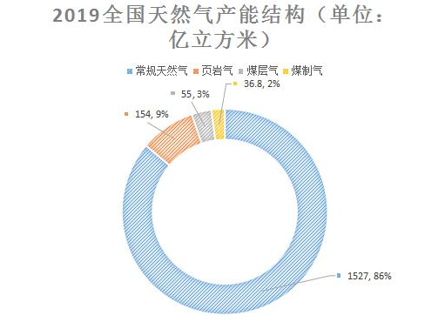

**其次，报告披露了国内的天然气生产以及消费利用情况。报告中指出，国内天然气生产目前阶段仍然主要以常规天然气资源为主，但是诸如页岩气、煤层气等新兴的非常规天然气资源，已经逐步在市场中展现出强大的活力。国内天然气利用情况同样从产能和消费两大版块进行阐述。而在产出和消费量的对比中，国内的天然气产量去年为1773 亿立方米，而消费量则高达3064 亿立方米，国内产-消缺口为1291亿立方米。缺口率达42%，国内天然气开采市场，例如撬装天然气液化设备的发展前景非常广阔。**

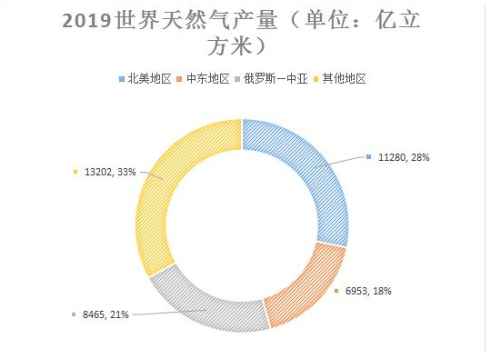**Secondly, the report discloses the domestic natural gas production, consumption and utilization. The report points out that at present, domestic natural gas production is still dominated by conventional natural gas resources, but emerging unconventional natural gas resources such as shale gas and coalbed methane have gradually shown strong vitality in the market. Domestic natural gas utilization is also described in terms of production capacity and consumption. In the comparison of output and consumption, the domestic natural gas output was 177.3 billion cubic meters last year, while the consumption was as high as 306.4 billion cubic meters, and the domestic production consumption gap was 129.1 billion cubic meters. The gap rate is 42%, and the development prospect of domestic natural gas exploitation market, such as skid mounted natural gas liquefaction equipment, is very broad.**

**根据上述报告内容可以发现，中国天然气的需求量大，而目前国内天然气的自给能力不足，是世界主要的天然气进口国，大力发展国内天然气利用市场对于维护我国资源安全有重要作用。基于此，必须要提高天然气能源设备制造与技术研发力度，迎接国内国际天然气行业发展的机遇和挑战。**

**According to the contents of the above report, it can be found that China has a large demand for natural gas, and the self-sufficiency of domestic natural gas is insufficient. It is a major natural gas importer in the world. Vigorously developing the domestic natural gas utilization market plays an important role in maintaining China's resource security. Based on this, we must improve the manufacturing and technology research and development of natural gas energy equipment to meet the opportunities and challenges of the development of domestic and international natural gas industry.**

1. **海上无人自动化垃圾处理平台**

**2. Marine unmanned automatic waste treatment platform**

**垃圾是一个全球性问题，随着世界人口增长、快速城市化和经济持续发展，全球每年产生的垃圾数量不断增长。由于垃圾处理能力不足，垃圾污染引起了全球疾病的传播、气候变化加剧、地下水污染、生物多样性减少、经济损失并增加洪水爆发的风险，从而影响人类的健康和生计。**

**Garbage is a global problem. With the world population growth, rapid urbanization and sustainable economic development, the amount of garbage produced in the world is increasing every year. Due to the lack of waste treatment capacity, waste pollution has caused the spread of global diseases, intensified climate change, groundwater pollution, biodiversity reduction, economic loss and increased the risk of flood outbreak, thus affecting human health and livelihood.**

**全球每年约有70一100亿吨城市废物产生，包括城市固体垃圾、商业和工业废料、建筑和拆迁垃圾等。至少有20亿人缺乏收集固体废物的途径、有30亿人没有处置废物的设施。非洲和亚洲的低收入城市，在未来15到20年中产生的固体废物将加倍。世界排名前50的大型垃圾站影响6400万人的日常生活。2014年全球产生了约4180万吨电子垃圾，比2010年增加了25%。这是世界上增长最快的垃圾种类，预计将在2018年达到5000万吨。研究认为，全球的海洋塑料垃圾主要来自5个国家——中国、印度尼西亚、菲律宾、泰国和越南。其中中国的塑料垃圾泄露量占全球的28%，被认为是最大的输出国。这些国家都在经历高速的经济增长，人民的消费水平爆炸式地增高，但垃圾处理设施却没有跟上。在我国的城镇地区，垃圾的收集率为65%，而农村地区仅为5%。农村地区通常采用一些非正规的垃圾处理方式，例如焚烧和倾倒入河道。令全球海洋“窒息”的塑料垃圾中，我国占了约30%。由佐治亚大学环境工程学教授詹娜·詹贝克主导的这项新研究估算，每年平均有800万吨塑料垃圾从全球192个沿海国家和地区排入海洋。其中130万到350万吨是由重度污染的中国沿海城市排放的。其中有一些不良“打包人”将回收的垃圾放在废弃的大船上仍由在公海里飘流直至沉没在海底。这对于海洋整个生态链来说无疑是非常大的伤害。**

**About 7-10 billion tons of municipal waste are generated every year in the world, including municipal solid waste, commercial and industrial waste, construction and demolition waste, etc. At least 2 billion people lack access to solid waste collection and 3 billion people do not have waste disposal facilities. Low income cities in Africa and Asia will double their solid waste generation in the next 15 to 20 years. The world's top 50 large garbage stations affect the daily lives of 64 million people. In 2014, the world generated about 41.8 million tons of e-waste, an increase of 25% over 2010. This is the fastest growing type of waste in the world and is expected to reach 50 million tons in 2018. The research shows that the global marine plastic waste mainly comes from five countries - China, Indonesia, the Philippines, Thailand and Vietnam. Among them, China's plastic waste leakage accounts for 28% of the world and is considered to be the largest exporter. These countries are experiencing rapid economic growth, and people's consumption level has increased explosively, but waste treatment facilities have not kept up. In China's urban areas, the garbage collection rate is 65%, while that in rural areas is only 5%. In rural areas, some informal waste disposal methods are usually used, such as incineration and dumping into rivers. China accounts for about 30% of the plastic waste that suffocates the global ocean. The new study, led by Jenna jenbeck, a professor of environmental engineering at the University of Georgia, estimates that an average of 8 million tons of plastic waste are discharged into the sea from 192 coastal countries and regions around the world every year. Of these, 1.3 million to 3.5 million tons were discharged from heavily polluted coastal cities in China. Among them, some bad "packers" put the recycled garbage on Abandoned Ships and still drift on the high seas until they sink on the seabed. This is undoubtedly a great harm to the whole marine ecological chain.**

**全球三分之二都是海洋，现如今土地资源已是寸土寸金，大量的生活垃圾就地掩埋已不是长久之计，焚烧的主流手段会大量污染环境，转而，将垃圾运送到海上来环保处理无疑是最佳选择。**

**Two thirds of the world is the sea. Now land resources are an inch of land and an inch of gold. It is not a long-term plan to bury a large amount of domestic waste on site. The mainstream means of incineration will pollute the environment. In turn, transporting waste to the sea for environmental treatment is undoubtedly the best choice.**

**水陆联运集装箱**

**3. Land and water intermodal container**

**国内集装箱租赁行业的发展现状、集装箱租赁发展挑战如何?根据全国第三方工商服务机构——天眼查查询结果，截止2021年6月31日，国内注册的工商企业中，业务范围包含“集装箱租赁”的企业(已注销、吊销的企业不包含在内)共有1647家，同比2020年增长121家，由此可看出新冠疫情对全球航运市场的影响正在逐渐减弱。另一方面，目前我国的建筑成本较低，人们的环保和安全意识不强。随着外贸结构的改变、内需市场的活跃以及环保和安全意识的逐渐增强，我国集装箱房屋市场将迎来巨大的发展契机。**

**What are the development status and challenges of domestic container leasing industry? According to the results of the national third party business service institution, "Tian Yan", as of June 31, 2021, there were 1647 registered businesses in China, including container leasing enterprises, which had been cancelled or revoked by enterprises, and increased by 121 over the same period in 2020. This shows that COVID-19's influence on the global shipping market is gradually weakening. On the other hand, at present, the construction cost in China is low, and people's awareness of environmental protection and safety is not strong. With the change of foreign trade structure, the activity of domestic demand market and the gradual enhancement of environmental protection and safety awareness, China's container housing market will usher in a huge development opportunity.**

**[集装箱租赁数量结构分析 2021集装箱租赁行业前景及现状报告](https://www.chinairn.com/report/20210818/091420485.html?id=1805605&name=liumingyue" \t "https://www.chinairn.com/news/20210901/_blank)**

**今年以来，集装箱租赁受益于总体疫情控制良好，我国外贸形势继续向好。本月中国出口集装箱运输市场行情继续保持良好态势，多条远洋航线运价走高，带动综合指数上涨。7月，上海航运交易所发布的中国出口集装箱综合运价指数平均值为2781.55点，较上月平均上涨12.0%。**

**Analysis on the quantity structure of container leasing 2021 report on the prospect and current situation of container leasing industry**

**Since this year, container leasing has benefited from the good control of the overall epidemic, and China's foreign trade situation has continued to improve. This month, China's export container transportation market continued to maintain a good trend, and the freight rates of many ocean routes rose, driving the rise of the comprehensive index. In July, the average value of China's export container comprehensive freight rate index released by Shanghai Shipping Exchange was 2781.55 points, an average increase of 12.0% over the previous month.**

**集装箱租赁租船市场受益于集运市场运价上涨，租船市场行情持续向好，多数[集装箱租赁](https://www.chinairn.com/report/20210818/091420485.html?id=1805605&name=liumingyue" \t "https://www.chinairn.com/news/20210901/_blank)价格有较大幅度上涨。澳新航线，德尔塔新冠病毒变异毒株的侵袭导致当地疫情有所反弹，集装箱租赁运输需求保持高位，供需基本面稳固，上海港船舶平均舱位利用率小幅上升，市场运价走高。7月，中国出口至澳新航线运价指数平均值为1876.30点，较上月平均上涨14.6%。**

**The container charter market benefited from the rise in freight rates in the centralized transportation market. The charter market continued to improve, and most container charter prices rose significantly. The New Zealand route, the attack of COVID-19 mutant strain caused a rebound in the local epidemic situation. The demand for container leasing and transportation remained high, the supply and demand fundamentals were stable, and the average utilization rate of ships in Shanghai port increased slightly, and the market price increased. In July, the average freight rate index of China's exports to Australia and New Zealand was 1876.30 points, an average increase of 14.6% over the previous month.**

**图表：2021H1国内集装箱租赁企业数量(单位：家)**

**Chart: number of domestic container leasing enterprises in 2021h1 (unit: units)**

**[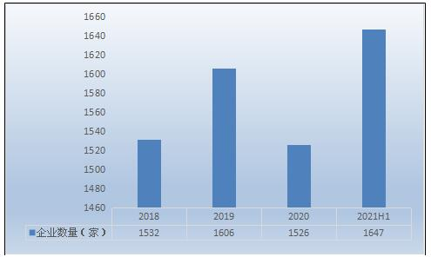](https://www.chinairn.com/report/20210818/091420485.html?id=1805605%26name=liumingyue)**

**资料来源：根据天眼查查询结果整理**

**Data source: sorted according to the query results of Tianyan search**

**国内集装箱租赁相关企业资产规模相差较大，既有资产规模数千亿元的企业，也有资产规模数千万元的企业，根据中国集装箱协会发布的统计数据显示，截止2021年上半年，国内集装箱租赁行业资产总规模达3.26万亿元，同比2020年集装箱租赁年底增长了0.29万亿元，增速达9.76%。**

**The asset scale of domestic container leasing related enterprises varies greatly, including enterprises with asset scale of hundreds of billions of yuan and enterprises with asset scale of tens of millions of yuan. According to the statistical data released by China Container Association, by the first half of 2021, the total asset scale of domestic container leasing industry had reached 3.26 trillion yuan, an increase of 0.29 trillion yuan compared with the end of 2020, The growth rate reached 9.76%.**

**图表：2021H1国内集装箱租赁行业资产规模(单位：万亿元)**

**Chart: asset scale of domestic container leasing industry in 2021h1 (unit: trillion yuan)**

**[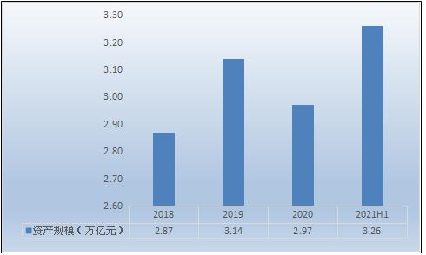](https://www.chinairn.com/report/20210818/091420485.html?id=1805605%26name=liumingyue)**

**资料来源：根据中国集装箱协会发布数据整理**

**Source: according to the data released by China Container Association**

**2021年上半年，所有集装箱船的平均速度为14.68节，同比增长4.9%，比上月增长0.3%，其中，新巴拿马集装箱船的速度为16.37节。集装箱租赁的高速将继续有利于[集装箱租赁](https://www.chinairn.com/report/20210818/091420485.html?id=1805605&name=liumingyue" \t "https://www.chinairn.com/news/20210901/_blank)运输市场。随着航速的提高，2021年4月至5月的货运量也在增加。其中，5月份为1687亿TEU-海里，几乎恢复到疫情前的水平。**

**In the first half of 2021, the average speed of all container ships was 14.68 knots, an increase of 4.9% year-on-year and 0.3% over the previous month. Among them, the speed of the new Panamanian container ship was 16.37 knots. The high speed of container leasing will continue to benefit the container leasing transportation market. With the increase of speed, the freight volume from April to may 2021 is also increasing. Among them, it was 168.7 billion TEU nautical miles in May, almost returning to the level before the epidemic.**

**水果蔬菜鲜花恒温保鲜集装箱，保鲜生产冷链物流基地。**

**4. Constant temperature fresh-keeping container for fruits, vegetables and flowers, and cold chain logistics base for fresh-keeping production.**

**冷链是指采用一定的技术手段，使易腐货物从采收加工、包装、贮藏、运输及销售的整个过程中都不间断地处于一定的适宜条件下，尽量降低货物质量的下降速度，最大程度地保持从庄稼地到餐桌的最佳质量，包括全面的冷藏解决方案和应用系统。**

**Cold chain refers to the use of certain technical means to keep perishable goods under certain suitable conditions continuously in the whole process of harvesting, processing, packaging, storage, transportation and sales, minimize the decline rate of goods quality and maintain the best quality from crop land to dining table to the greatest extent, including comprehensive refrigeration solutions and application systems.**

**目前发达国家已普遍采用规范配套的果蔬保鲜流通，从预冷、储藏、洗果、涂蜡、冷冻运输等方面进行保鲜处理的果菜占总产量的80%。而我国尽管已经陆续开始应用集装箱冷藏、普通冷藏车、海运冷藏集装箱、铁路冷藏车等方式，但绝大多数果菜还是一采摘下来就直接进入市场，上市销售的都是初始和半初始农产品，没有任何预冷、保鲜的处理措施，果菜失去巨大的增值机会和空间。随着我国冷链保鲜物流的发展，各地已经出现了比较有代表性的水果和蔬菜品种，给当地农户和销售企业带来了巨大的增收空间。**

**At present, the standard supporting fresh-keeping circulation of fruits and vegetables has been widely used in developed countries. The fresh-keeping treatment of fruits and vegetables from the aspects of pre cooling, storage, fruit washing, waxing, freezing and transportation accounts for 80% of the total output. Although container refrigeration, ordinary refrigerated truck, marine refrigerated container, railway refrigerated truck and other methods have been successively applied in China, the vast majority of fruits and vegetables still enter the market directly as soon as they are picked. What they are listed and sold are initial and semi initial agricultural products. Without any pre cooling and fresh-keeping treatment measures, fruits and vegetables lose huge value-added opportunities and space. With the development of cold chain preservation logistics in China, there have been more representative varieties of fruits and vegetables, which has brought huge income increasing space to local farmers and sales enterprises.**

**农产品冷链保鲜产业是产后农业重要一环，进一步延伸现代农业产业链，是农产品从产地收购之后，在产品加工、贮藏、运输、分销和零售直到消费者手中，其各个环节始终处于产品所必需的低温环境下，以保证食品质量安全，减少损耗，防止污染的特殊供应链系统，对促进农民大幅增收具有重要意义。但由于当前我国果蔬产后保鲜、冷链物流产业应用范围狭窄、发展滞后，每年的果菜的损失浪费率仍然十分惊人。有关统计数字显示，我国目前食品低温物流主要分为几大类：冷饮、肉制品、速冻食品、乳制品、水产品，以及水果和蔬菜。其中，2010年我国水果总产量为13000万吨，蔬菜总产量为8.6亿吨，相当一部分需要低温物流。但目前，我国水果和蔬菜总量中只有10%至20%利用了低温物流，品种也仅限于一些经济效益比较高的水果，而发达国家一般在90%左右。**

**The cold chain preservation industry of agricultural products is an important part of postpartum agriculture. It further extends the modern agricultural industrial chain. After the purchase of agricultural products from the origin, all links of agricultural products are always in the low-temperature environment necessary for the products from product processing, storage, transportation, distribution and retail to consumers, so as to ensure food quality and safety and reduce consumption, The special supply chain system to prevent pollution is of great significance to promote the substantial increase of farmers' income. However, due to the narrow application scope and lagging development of China's post natal preservation of fruits and vegetables and cold chain logistics industry, the annual loss and waste rate of fruits and vegetables is still very amazing. Relevant statistics show that China's current food low-temperature logistics is mainly divided into several categories: cold drinks, meat products, quick-frozen food, dairy products, aquatic products, as well as fruits and vegetables. Among them, in 2010, the total output of fruits and vegetables in China was 130 million tons and 860 million tons, a considerable part of which needed low-temperature logistics. However, at present, only 10% to 20% of the total amount of fruits and vegetables in China use low-temperature logistics, and the varieties are only limited to some fruits with high economic benefits, compared with about 90% in developed countries.**

**据有关资料显示，现阶段我国水果、蔬菜的年冷藏量约占总产量的10%，冷链流通率仅为5%，果蔬采后的商品化处理率不足30%，果蔬物流损失率高达30－40%，而发达国家的果疏物流损失率可控制在5%以下。目前全国约有90%以上的新鲜水果、蔬菜及其制品基本上处在没有冷链保证的条件下运销。国家农产品保鲜工程技术研究中心研究发现，我国每年生产的水果蔬菜从田间到餐桌，损失率高达25%至30%，年损失价值近800亿元人民币；而发达国家的果蔬损失率则普遍控制在5%以下，美国果蔬在保鲜物流环节的损耗率仅有1%至2%。**

**According to relevant data, at present, the annual cold storage capacity of fruits and vegetables in China accounts for about 10% of the total output, the cold chain circulation rate is only 5%, the post harvest commercialization treatment rate of fruits and vegetables is less than 30%, and the logistics loss rate of fruits and vegetables is as high as 30-40%, while the logistics loss rate of fruits and vegetables in developed countries can be controlled below 5%. At present, more than 90% of fresh fruits, vegetables and their products are basically transported and sold without cold chain guarantee. The National Agricultural Products Preservation Engineering Technology Research Center found that the annual loss rate of fruits and vegetables produced in China is as high as 25% to 30% from the field to the table, and the annual loss value is nearly 80 billion yuan; The loss rate of fruits and vegetables in developed countries is generally controlled below 5%, and the loss rate of fruits and vegetables in fresh-keeping logistics in the United States is only 1% to 2%.**

**上世纪90年代初，我国种植业开始向优势地区集中，但由于保鲜技术不过硬、产业化经营程度低，各个果蔬主产区普遍陷入了产品储不进、运不出的尴尬境地，为了避免果菜白白烂掉，农民无奈之下只能地产地销、季产季销，严重影响了产地农民的增收和种植积极性。这种尴尬格局至今没有打破。现代保鲜物流产业的快速发展，能对农民增产增收起到较大的促进作用。以农村种植面积较大的蒜薹（豆角、黄瓜、萝卜、茄子、辣椒、西红柿、富士苹果、籽瓜、西瓜等是平川区主打品种）为例，2010年全国蒜薹的种植面积只有500多万亩，而随着近年来我国蒜薹保鲜水平的快速提高，国内种蒜农民一亩地普遍增加了800多元的产后收益，农民积极性的提高使得我国大蒜种植面积10多年的时间里增长了5倍，并显著促进了大蒜的出口，如今我国已经是世界上大蒜产量和出口量第一大国。2010年，我国蒜薹总产约30亿斤，冷藏量达到了18亿斤，60%实现了冷藏，在所有蔬菜品种中，蒜薹的冷藏储量和比例都是最大的。**

**In the early 1990s, China's planting industry began to concentrate in advantageous areas. However, due to the poor preservation technology and low degree of industrialized operation, the main fruit and vegetable producing areas generally fell into the embarrassing situation that products could not be stored and transported. In order to avoid the rot of fruits and vegetables in vain, farmers had no choice but to sell real estate, produce and sell quarterly, It has seriously affected the income increase and planting enthusiasm of farmers in producing areas. This embarrassing pattern has not been broken. The rapid development of modern fresh-keeping logistics industry can greatly promote the increase of farmers' production and income. Taking garlic stalks with large planting area in rural areas (beans, cucumbers, radishes, eggplants, peppers, tomatoes, Fuji apples, seed melons and watermelon are the main varieties in Pingchuan District) as an example, in 2010, the planting area of garlic stalks in China was only more than 5 million mu. With the rapid improvement of the freshness preservation level of garlic stalks in China in recent years, the postpartum income of garlic farmers in China has generally increased by more than 800 yuan per mu, The improvement of farmers' enthusiasm has increased the planting area of garlic in China by five times in more than 10 years, and significantly promoted the export of garlic. Now China is the largest country in garlic production and export in the world. In 2010, the total output of garlic bolt in China was about 3 billion kg, and the cold storage capacity reached 1.8 billion kg, 60% of which was refrigerated. Among all vegetable varieties, the cold storage reserves and proportion of garlic bolt are the largest.**

**根据市场需求及企业发展需要，公司后期将投资60万个水果蔬菜鲜花恒温保鲜集装箱作为租赁，全面建成国内冷链生态保护运输体系。**

**According to the market demand and enterprise development needs, the company will invest 600000 constant temperature fresh-keeping containers of fruits, vegetables and flowers as leases in the later stage to fully build the domestic cold chain ecological protection transportation system.**

1. **金融板块**

**三、 Financial sector**

**我国金融衍生产品市场的扩大和开放，正迎合了当今经济全球化的趋势，自身发展的同时也给世界带来了机遇。**

**The expansion and opening of China's financial derivatives market is catering to the trend of economic globalization. Its own development also brings opportunities to the world.**

**首先，金融衍生产品市场的发展有利于降低企业和金融机构的经营成本，投资风险，提高其经营效益，因此提高了企业和金融机构的综合竞争力。**

**First of all, the development of financial derivatives market is conducive to reduce the operating costs and investment risks of enterprises and financial institutions and improve their operating efficiency. Therefore, it improves the comprehensive competitiveness of enterprises and financial institutions.**

**其次，金融衍生产品市场的发展能够加深大型国有企业和金融机构对自身的市场意识，加强管理水平，使其更好地与国际多样化方式接轨。此外，金融衍生产品市场的发展还促进了我国经济的发展，提高了我国综合经济竞争力，提升了国际影响力。**

**Secondly, the development of financial derivatives market can deepen the market awareness of large state-owned enterprises and financial institutions, strengthen the management level, and make them better in line with international diversification. In addition, the development of financial derivatives market has also promoted China's economic development, improved China's comprehensive economic competitiveness and enhanced its international influence.**

**最后，我国金融衍生产品市场的发展给世界其他国家经济发展带来了机遇，随着我国金融市场的对外开放，增加了各国与中国的合作，实现双方互利共赢。**

**Finally, the development of China's financial derivatives market has brought opportunities to the economic development of other countries in the world. With the opening of China's financial market to the outside world, it has increased the cooperation between countries and China to achieve mutual benefit and win-win results.**

**所以，即使存在一些客观问题，当今我国金融衍生品市场仍然具有良好的发展前景，中国应该把握好机会，大力发展经济，实现人均GDP强国。**

**Therefore, even if there are some objective problems, China's financial derivatives market still has good development prospects. China should seize the opportunity to vigorously develop the economy and achieve a powerful country with per capita GDP.**

1. **农业“农光互补”光伏板块**

**四、 Agricultural "agriculture light complementary" photovoltaic plate**

**据统计，全球集中式光伏发电项目略多于分布式发电项目，事实上国外光伏行业以分布式为主。**

**According to statistics, the global centralized photovoltaic power generation projects are slightly more than distributed power generation projects. In fact, the foreign photovoltaic industry is mainly distributed.**

**日本农林水产领域在2013年放宽了有关农业型光伏发电的规定:若发电设备的阴影造成的农作物减收比例在20%以内，则支柱的地基部分便认可转用为暂时性农用地。澳大利亚、美国等地域宽广的农业大国则较多为光伏屋顶发电，较少与农业结合。现阶段，欧美地区政府补贴下调，光伏投资者积极性降低，短期，农业光伏的进展缓慢。**

**In the field of agriculture, forestry and Fisheries in Japan, the regulations on agricultural photovoltaic power generation were relaxed in 2013: if the crop income reduction caused by the shadow of power generation equipment is less than 20%, the foundation part of the pillar will be recognized as temporary agricultural land. Large agricultural countries such as Australia and the United States are more photovoltaic roof power generation and less combined with agriculture. At this stage, government subsidies in Europe and the United States are reduced, the enthusiasm of photovoltaic investors is reduced, and the progress of agricultural photovoltaic is slow in the short term.**

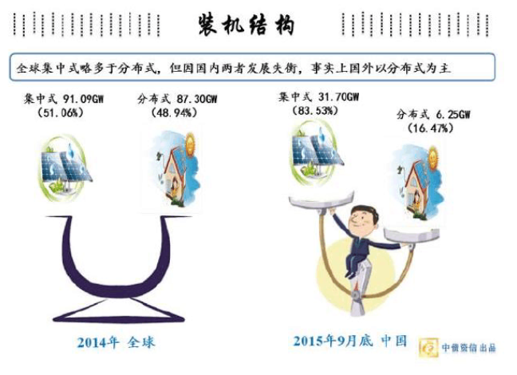

**相较国外光伏形式，我国集中式和分布式电站发展失衡，投资太阳能电站，需要高度密集的资金，和集中的管理。这就意味着通常，投资大型太阳能电站需要占用大量的面积，这个面积在分布式屋顶较难获得。于是，在荒地投资大型电了世界第的装机量。**

**Compared with foreign photovoltaic forms, the development of centralized and distributed power stations in China is unbalanced. Investing in solar power stations requires highly intensive funds and centralized management. This means that investment in large-scale solar power plants usually takes up a large area, which is difficult to obtain on distributed roofs. As a result, investing in large-scale electricity in wasteland has increased the world's installed capacity.**

**但是，在西部的荒漠地区投资太阳能电站，出现了消纳的问题，严重的地区.由于无法消纳分布式太阳能电力，电网出于安全考虑，对太阳能电力输出进行了计划性限制，导致太阳能电站投资的收益降低。于是，往东部地区投资大型电站，变成了主流的应用方式。**

**However, the investment in solar power plants in the desert areas of the West has the problem of absorption. In serious areas, due to the inability to absorb distributed solar power, the power grid has planned restrictions on the output of solar power for security reasons, resulting in the reduction of the income of solar power plant investment. Therefore, investing in large-scale power stations in the eastern region has become the mainstream application mode.**

**在国务院《关于促进光伏产业健康发展的若干意见》及一系列配套政策支持下，国内光伏应用市场迎来爆发式增长，全国因地制宜，优势互补，以农光、渔光、风光等多能互补方式来建设光伏电站，其项目具备经济性和推广性.有助缓破解大规模可再生能源接入电网的瓶颈，大有“助燃”因内光伏应用市场之势。这种农光互补、渔光互补、组合电源点的新模式，既优化了光伏电能质量、避免了“弃光”，又提高了电网的调节能力和送出电线的利用率。**

**With the support of several opinions on promoting the healthy development of photovoltaic industry issued by the State Council and a series of supporting policies, the domestic photovoltaic application market has ushered in explosive growth. The country adapts measures to local conditions, complements its advantages, and constructs photovoltaic power stations in the form of multi energy complementation such as agricultural light, fishing light and scenery, The project is economical and popularized, which helps to slow down the bottleneck of large-scale renewable energy access to the power grid, and has the potential of "supporting combustion" in the domestic photovoltaic application market. This new mode of agricultural light complementation, fishing light complementation and combined power points not only optimizes the photovoltaic power quality, avoids "light abandonment", but also improves the regulation capacity of the power grid and the utilization rate of the outgoing wires.**

**然而，东部地区缺少平坦的荒地，太阳能和温室大棚是太阳能占用排地的一个特殊的解决方案， 于是，就出现了很多光伏大棚“现代化农业”然后，很多人为了投机取巧，建立了看起来像大棚，其实是太阳能电站的“光伏大棚”。**

**However, the eastern region lacks flat wasteland. Solar energy and greenhouse are a special solution for solar energy to occupy and row land. Therefore, there are many photovoltaic greenhouses "modern agriculture". Then, in order to be opportunistic, many people have established "photovoltaic greenhouses" that look like greenhouses but are actually solar power plants.**

**国家能源局，在近期也出台了规范太阳能和农业结合的使用规范，太阻能电站如果建立在具有“产权”的建筑物上，只能算分布式太阳能电站，而没有产权的临建或大棚上，必须经过大型电站的严格可行性审批，防止对耕地资源的低效占用。**

**The national energy administration has also recently issued a code to regulate the use of solar energy combined with agriculture. If the too energy blocking power station is built on a building with "property rights", it can only be regarded as a distributed solar power station, while the temporary buildings or greenhouses without property rights must be subject to the strict feasibility approval of large-scale power stations to prevent the inefficient occupation of cultivated land resources.**

**第四章 商业模式**

**Chapter IV Business Model**

**钢铁板块**

**一、 Steel plate**

**① 投资自营：在废旧钢铁较多的国家，设立回收站点，再建立一家加工点，投入自动球磨机（每小时加工500吨左右，）设备运至加工点，将回收回来的钢铁运至自己设立的加工点，统一加工至国内允许进口的标准，再集中至较大港口，用集装箱装运至我国港口，同时总部市场部在国内签订稳定的购销合同，货物到达客户指定的港口，清关完成之后，客户付款，货物交接。**

**① Self Investment: in countries with a large number of waste steel, set up recycling stations, establish a processing point, input automatic ball mill (processing about 500 tons per hour) equipment to transport to the processing point, transport the recovered steel to the processing point set up by ourselves, process it to the domestic allowable import standard, then concentrate it to large ports and ship it to Chinese ports in containers, At the same time, the marketing department of the headquarters signs stable purchase and sales contracts in China. The goods arrive at the port designated by the customer. After customs clearance, the customer pays and the goods are handed over.**

**② 招商加盟：总部设立全球招商加盟中心，通过当地媒体将我们的招商信息广告出去，让有废旧钢铁回收渠道的中小型公司主动联系我们。同时可以把加工也交给当地经销商，从回收到加工，再到运输至当地港口的全部工作都交由经销商完成。**

**② Investment promotion and joining: the headquarters set up a global investment promotion and joining center to advertise our investment promotion information through local media, so that small and medium-sized companies with waste steel recycling channels can take the initiative to contact us. At the same time, the processing can also be handed over to the local dealer, and all the work from recycling to processing to transportation to the local port can be completed by the dealer.**

**③投资并购：全球范围内收购一些大规模的拆船厂和废旧钢铁回收加工公司，公司通过各项风险调查之后，将其并购至我司旗下，作为我司全资子公司服务于我司旗下。**

**③ Investment and M &amp; A: the company acquired some large-scale ship dismantling plants and waste steel recycling and processing companies worldwide. After passing various risk investigations, the company merged them into our company and served our company as a wholly-owned subsidiary.**

**利润分析**

**以回收废旧钢铁为例**

**①中国炼钢厂回收价格：3000元/吨CN**

**全球回收价格：1200元/吨CN 加工80元CN/吨 运输300元CN/吨 公司运营100元/吨 税300元CN/吨**

**毛利：1120元CN/吨**

**每船运输：10万吨 每月50船 500万吨 500万吨*1120元=56亿元CN 年毛利：666亿元CN**

**Profit analysis**

**Taking the recycling of waste steel as an example**

**① Recycling price of China's steel mills: 3000 yuan / ton cn**

**Global recycling price: 1200 yuan / ton CN processing: 80 yuan / ton CN transportation: 300 yuan / ton company operation: 100 yuan / ton tax: 300 yuan / ton cn**

**Gross profit: 1120 yuan CN / ton**

**Transportation per ship: 100000 tons, 500000 ships per month, 5 million tons, 5 million tons * 1120 yuan = 5.6 billion yuan CN, annual gross profit: 66.6 billion yuan cn**

**石油化工**

**二、 Petrochemical Industry**

**1.海上无人自动化垃圾处理平台**

**1. Marine unmanned automatic waste treatment platform**

**近海岸线200公里公海上建成多个无人自动化垃圾处理平台。将实行会员制度收费，回收来的垃圾可分有有机物以及无机物两大类处理，有机物我们将通过科学手段将其做海洋饲料，投放至大海。无机物我们将有用的废物利用，如废旧钢铁、废旧轮胎、废旧塑料、废旧电子、废旧金属等。其他无用的无机物将制作成大小不一的固体块，沉如大海。**

**A number of unmanned automatic waste treatment platforms have been built on the high seas 200 kilometers away from the coastline. The membership system will be implemented. The recycled garbage can be divided into two categories: organic and inorganic. We will use organic matter as marine feed and put it into the sea through scientific means. Inorganic materials we will use useful wastes, such as waste steel, waste tires, waste plastics, waste electronics, waste metals, etc. Other useless inorganic materials will be made into solid blocks of different sizes and sink like the sea.**

**利润分析**

**Profit analysis**

**前期将通过入会成为会员的形式收取会员费，入会仅仅是门槛，有一定的额度，这个额度就是垃圾处理的重量，例如：处理一吨生活垃圾200美元，每年处理5亿吨垃圾，收益一仟亿美元。电子垃圾，每年处理1亿吨可回收各种贵金属，每吨收益5百美元，共计5百亿美元。工业垃圾每年处理2亿吨，每吨收益3百美元，共计6百亿美元。核工业垃圾每年处理2百万吨，每吨收益3仟美元，共计60亿美元。石油化工海洋污染垃圾，每年处理一千万吨，每吨收益250美元，共计25亿美元。太空垃圾，每年回收5百万公斤，每公斤收益1万美元，共计5亿美元。后期处理垃圾额度不足的话还需要充值才可将垃圾往平台投放。**

**In the early stage, the membership fee will be charged in the form of membership. Membership is only the threshold, and there is a certain amount, which is the weight of waste treatment. For example, the treatment of one ton of domestic waste is US $200, 500 million tons of waste are treated every year, and the income is US $100 billion. E-waste can process 100 million tons of recyclable precious metals every year, with a revenue of $50 per ton, a total of $50 billion. 200 million tons of industrial waste are treated every year, with a revenue of $30 per ton, a total of $60 billion. 2 million tons of nuclear waste are treated every year, with a revenue of $3000 per ton, totaling $6 billion. Petrochemical marine pollution waste is treated with 10 million tons every year, with a revenue of US $250 per ton, a total of US $2.5 billion. Space waste is recycled by 5 million kilograms every year, with a revenue of $10000 per kilogram, a total of $500 million. If the amount of post-treatment waste is insufficient, it needs to be recharged before the waste can be put on the platform.**

**2.建成水陆联运,30万个LNG撬装设备罐，x每个60万元=共计180亿元人民币，30万个LPG撬装设备罐，x每个30万=共计90亿元人民币。**

**2. Build land and water combined transport, 300000 LNG skid mounted equipment tanks, X 600000 yuan each = 18 billion yuan in total, 300000 LPG skid mounted equipment tanks, X 300000 yuan each = 9 billion yuan in total.**

**水果蔬菜鲜花恒温保鲜集装箱车辆10吨10万辆，x10万元=共计100亿元人民币，15吨10万辆x15万元=共计150亿元人民币，20吨10万辆x20万元=共计200亿元人民币，25吨10万辆x25万元=共计250亿元人民币，30吨10万辆x30万元=共计300亿元人民币，冷冻各类车辆投资300亿元人民币。**

**Fruits, vegetables, flowers, constant temperature and fresh-keeping container vehicles: 10 tons, 100000 vehicles, x 10 million yuan = 10 billion yuan in total, 15 tons, 100000 vehicles, x 15 million yuan = 15 billion yuan in total, 20 tons, 100000 vehicles, x 20 million yuan = 20 billion yuan in total, 25 tons, 100000 vehicles, x 25 million yuan = 25 billion yuan in total, 30 tons, 100000 vehicles, x 30 million yuan = 30 billion yuan in total, and 30 billion yuan in all kinds of frozen vehicles.**

**水陆联运20尺集装箱500万个，x每个投资1万8仟元=共计900亿元人民币，40尺500万个x每个投资3万6仟元=共计1800亿元人民币。**

**There are 5 million 20 foot containers through water and land transportation, X each investment of 18000 yuan = a total of 90 billion yuan, 40 foot 5 million x each investment of 36000 yuan = a total of 180 billion yuan.**

**利润分析**

**Profit analysis**

**30万个LNG撬装设备，包括危险化学品罐，每天收费标准每个667元30万个x1800天=3600亿元人民币。**

**300000 LNG skid mounted equipment, including hazardous chemical tanks, with a daily charging standard of RMB 667 per day, 300000 x 1800 days = RMB 360 billion.**

**30万个LPG撬装设备包括各种石油产品罐，每天收费标准每个335元30万个x1800天=1800亿元人民币**

**300000 LPG skid mounted equipment, including various petroleum product tanks, with a daily charging standard of RMB 335 per day, 300000 x 1800 days = RMB 180 billion**

**60万车辆水果蔬菜鲜花恒温保鲜集装箱冷冻各类车辆，综合吨位1200万吨每天收费标准每吨150元1200万吨x1800天=3240亿元人民币。**

**600000 vehicles, fruits, vegetables, flowers, constant temperature fresh-keeping containers, frozen all kinds of vehicles, with a comprehensive tonnage of 12 million tons. The daily charging standard is 15 yuan per ton, 12 million tons x 1800 days = 324 billion yuan.**

**20尺集装箱500万个，每个20尺集装箱每天收费标准每个20元500万个x1800天=1800亿元人民币。**

**There are 5 million 20 foot containers, and the daily charging standard for each 20 foot container is RMB 200000, 5 million x1800 days = RMB 180 billion.**

**40尺集装箱每天收费标准每个40元500万个x1800天=3600亿元人民币。**

**The daily charging standard for 40 foot containers is RMB 4000000 for each 5 million x1800 days = RMB 360 billion.**

**金融板块**

**三、 Financial sector**

**贵重金属投资1000个亿（资金池）总体规模10万个亿**

**The investment in precious metals is 100 billion (capital pool), and the overall scale is 100000 billion**

**分公司将100%培养残疾人经营管理，除了给残疾人提供就业机会的同时，都将认购我司总部价值5万~10万元不等的金融产品，（国家对残疾人提供人民币5万至10万元的创业基金）将按年利率的形式，参与分红。举例：一家分公司中有10个残疾人，其中10人都购买我司5万元金融产品。一家分公司10×5万=50万元。3000家分公司：50万×3000=15亿元。**

**The branch will train 100% operation and management of the disabled. In addition to providing employment opportunities for the disabled, it will subscribe for financial products with a value of 50000-100000 yuan from our headquarters (the state provides a venture fund of 50000-100000 yuan for the disabled) and participate in dividends in the form of annual interest rate. For example, there are 10 disabled people in a branch, of which 10 people buy our financial products of 50000 yuan. A branch 10 × 50000 = 500000 yuan. 3000 branches: 500000 × 3000 = 1.5 billion yuan.**

**农业“农光互补”光伏板块**

**四、Agricultural "agriculture light complementary" photovoltaic plate**

**1.与当地村委会进行全面合作，当地村委直接入股;我方提供建设资金、养殖技术(设立水产研究所)、建立建立大型水产交易批发市场，打入国内外商贸市场:建设大型冷冻库及水产精加工厂进行水产品、农产品加工。**

**1. Fully cooperate with the local village committee, and the local village committee directly takes shares; We provide construction funds, aquaculture technology (establish Aquatic Research Institute), establish large aquatic trading wholesale markets, and enter domestic and foreign commercial markets: build large-scale freezers and aquatic fine processing plants for the processing of aquatic products and agricultural products.**

**2.村委会提供养殖场所(非农田用地难涂池塘低洼、原渔池)和养殖人员。充分调动当地村民的积极性，对村民进行高科技技术和水产养殖的培训，解决部分村民的就业。**

**2. The village committee provides breeding sites (non farmland land, difficult to paint ponds, low-lying, original fishing ponds) and breeding personnel. Fully mobilize the enthusiasm of local villagers, train villagers in high-tech technology and aquaculture, and solve the employment of some villagers.**

**3.直接向当地村委会租赁非农田用地、滩涂、池塘低洼、聘用部分当地村民，解决部分村民的就业问题。**

**3. Directly lease non farmland land, beaches and low-lying ponds from the local village committee, hire some local villagers, and solve the employment problem of some villagers.**

**4.与当地水产养殖户直接签署合作合作(村民提供现有的养殖池塘)我方提供资金改造养殖场为光伏养殖大棚，棚顶发电，池塘养殖水产养殖方面双方合作，按利润分成。**

**4. Directly sign cooperation with local aquaculture farmers (villagers provide existing aquaculture ponds). We provide funds to transform the aquaculture farm into photovoltaic aquaculture greenhouses, ceiling power generation, pond aquaculture and aquaculture. The two sides cooperate and share the profits.**

**5.我们只收取租金。相比于传统的农业光伏大棚，我们的材料都是由铝、玻璃来打造的温室，虽然前期成本较大，但后期铝回收也是一部分的收益来源。将个别区域打包给中间承包商，其中成立3000家分公司的的数据管理，建立其属于自己的国内农业数据库。后期有用的数据也可以向各大资源网站有偿出售。**

**5. We only charge rent. Compared with traditional agricultural photovoltaic greenhouses, our materials are greenhouses made of aluminum and glass. Although the initial cost is large, the later aluminum recovery is also a part of the income source. Package individual areas to intermediate contractors, set up data management of 3000 branches and establish their own domestic agricultural database. Later useful data can also be sold to major resource websites for compensation.**

**第五章 运营管理**

**Chapter V operation management**

**一、分公司成立初期**

**一、 Initial stage of branch establishment**

**计划先在全国各县级开办30家分公司，永达（香港）实业有限公司作为总部将向30家分公司每家提供5000万元金融产品，每家将5000万金融产品销售完毕后。留1000万分公司前期自用，剩余4000万交给总公司。**

**It is planned to set up 30 branches at all counties in China. Yongda(hongkong) Industrial Co., Ltd., as the headquarters, will provide 50 million yuan of financial products to each of the 30 branches, and each will sell 50 million yuan of financial products. 10 million yuan is reserved for the company's own use in the early stage, and the remaining 40 million yuan is handed over to the head office.**

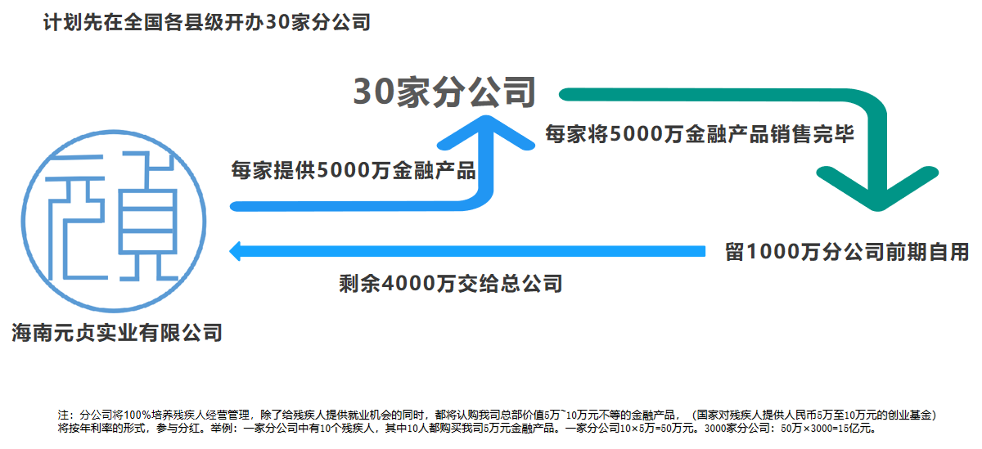

**二、分公司人员方面**

**二、 Branch personnel**

**将于全国残疾人联合会合作，每个分公司安置复员转业军人员10名作为公司经营管理人员工资由总公司发放.五险一金总公司负责缴纳。每个分公司安置社会90名残疾人员，100%培养残疾人经营管理工作，工资总公司发放，五险一金总公司负责缴纳。每个分公司经营场所500平方米至1000平方米之间，如果地方政府支持可由政府提供，政府有困难，由分公司选址租赁总公司出资，发展起来在扩大营业面积，固定就业残疾人员90名作为骨干力量，工资由总公司发放，带动全区域残疾人员参与实业创业经营。**

**In cooperation with the national disabled persons' Federation, 10 demobilized and demobilized military personnel will be resettled in each branch. As the company's operation and management personnel, the salary will be paid by the head office. The head office is responsible for paying the five insurances and one fund. Each branch resettled 90 disabled people, trained 100% of the disabled people for operation and management, paid wages by the head office, and paid five insurances and one fund by the head office. Each branch's business site is between 500 square meters and 1000 square meters. If the local government supports it, it can be provided by the government. If the government has difficulties, it will be funded by the branch's location leasing head office. It will expand its business area, fix 90 employed disabled people as the backbone, and the wages will be paid by the head office to drive the disabled people in the whole region to participate in industrial entrepreneurship.**

**公司人员100名，复转军人10名，残疾人员九十名。其中总经理人一名，副经理二名，销售总监一名，办公室主任一名，财务人员二名。**

**The company has 100 employees, 10 demobilized soldiers and 90 disabled people. One general manager, two deputy managers, one sales director, one office director and two financial personnel.**

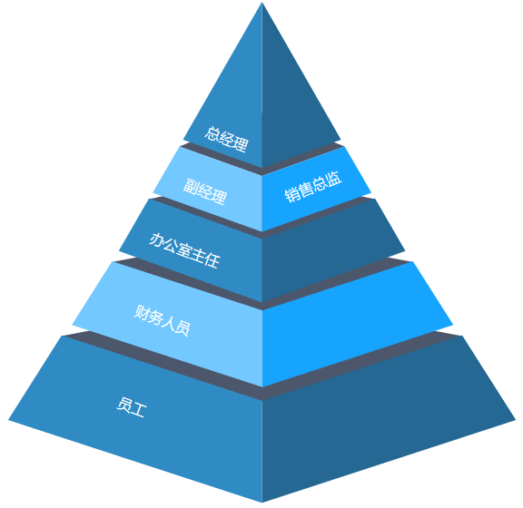

**三、培养残疾人的目的。**

**三、 The purpose of training the disabled.**

**1.建立创业人就业人员健康档案**

**1. Establish health records of entrepreneurs and employees**

**1.1据不完全统计，我国目前有8300万残疾人，占总人口的6.38%.我国残疾人的数量比世界上许多国家的总人口还要多，由此可见我国残疾人事业发展之艰巨和重大。改革开放以来特别是近年来，国家对残疾人事业非常重视，2006年6月4日和2010年3月10日，国务院办公厅相继批准转发了《中国残疾人事业“十一五”发展纲要（2006年-2010年）》，和《关于加快推进残疾人社会保障体系和服务体系建设的指导意见》等文件，对推动我国残疾人事业的发展发挥了至关重要的作用。**

**1.1 according to incomplete statistics, there are 83 million disabled persons in China, accounting for 6.38% of the total population. The number of disabled persons in China is more than the total population of many countries in the world. Therefore, it can be seen that the development of the cause of disabled persons in China is arduous and significant. Since the reform and opening up, especially in recent years, the state has attached great importance to the cause of persons with disabilities. On June 4, 2006 and March 10, 2010, the general office of the State Council successively approved and transmitted the outline for the development of China's cause for persons with disabilities in the eleventh five year plan (2006-2010) and the guiding opinions on accelerating the construction of social security system and service system for persons with disabilities, It has played a vital role in promoting the development of the cause of the disabled in China.**

**1.2这两个文件都提到了加强残疾人事业信息化建设问题，《中国残疾人事业“十一五”发展纲要（2006年-2010年）》明确提出，加强残疾人事业信息化建设是国家政务信息化建设的整体要求，是实现残疾人事业现代化管理和可持续发展的重要措施。 《关于加快推进残疾人社会保障体系和服务体系建设的指导意见》更进一步指出，“到2015年，建立起残疾人“两个体系”基本框架，使残疾人基本生活、医疗、康复、教育、就业等基本需求得到制度性保障，残疾人生活状况进一步改善”。**

**1.2 both documents mentioned the issue of strengthening the informatization construction of the cause for the disabled. The "Eleventh Five Year Plan" development outline of China's cause for the disabled (2006-2010) clearly stated that strengthening the informatization construction of the cause for the disabled is the overall requirement of the national government informatization construction and an important measure to realize the modern management and sustainable development of the cause for the disabled. The guiding opinions on accelerating the construction of social security system and service system for the disabled further pointed out that "by 2015, the basic framework of" two systems "for the disabled will be established, so that the basic needs of the disabled such as basic life, medical treatment, rehabilitation, education and employment can be systematically guaranteed, and the living conditions of the disabled will be further improved".**

**1.3正是基于以上原因，我们迫切需要建成一个残疾人直接参与实业创业的组织，不做免税工具，要有正常人一样自尊心，要做到比正常人对国家，对社会主义建设有更多贡献的人，建立健康及服务体系信息化体系。网络建成后，丰富的信息资源，为领导和政府相关部门进行宏观管理、调控和决策提供基础数据，更能为残疾人创业就业提供方便、快捷和有效的服务。**

**1.3 for the above reasons, we urgently need to build an organization for the disabled to directly participate in industrial entrepreneurship, do not make tax-free tools, have the same self-esteem as normal people, and establish an information system of health and service system for people who have made more contributions to the country and socialist construction than normal people. After the completion of the network, rich information resources provide basic data for leaders and relevant government departments to carry out macro management, regulation and decision-making, and can provide convenient, fast and effective services for the entrepreneurship and employment of the disabled.**

**1.4建立创业人就业人员健康档案，健康档案是以人为本的大数字化档案，记录了一个人从出生至死亡整个生命历程的医疗保健信息，通过健康档案，实现个人创业就业健康信息在不同的医疗机构之间交换和共享，使得病人不需要在医院间不断重复检查，并可实现对个人创建就业健康的评估和干预，进一步加强对个人创业就业健康的管理和防预。信息技术是医疗卫生服务的服务效率和服务质量的提高的重要手段之一，共享的医疗信息更能够贯穿医护过程、横跨医疗服务、跨越地理位置，从而有效的控制医疗费用不断增长、提高医疗服务水平和质量。鉴于残疾人的特殊性，我们必须为其量身定做一套适用的创业就业健康信息网络，既方便于残疾人就医，又便于政府相关部门和社会爱心人士了解残疾人的创业就业基本情况和动态信息，从而方便于政府有针对性的决策调整和爱心人士对口支持赞助。本项目计划，充分利用现代信息化技术，建设一个全国统一的残疾人创业就业健康卡应用大数据系统，实现业务信息互联共享。创业就业健康卡主要应用在创业就业，就诊、保健、计划免疫、保健咨询等方面，其主要功能有：识别持卡者在创业就业，医疗卫生各项业务中的合法身份，并作为办理业务的电子凭证；替代手工完成信息录入，增强大数据真实性和准确性，提高工作效率；在信息网络建设先期不完善的情况下，辅助网络准确性，实现医疗卫生业务有关信息的收集和交换，完成信息识别；实现公司业务的电子化办公和社会化运行，增强管理部门的管理力度，增强业务的透明度，实现各项业务的信息共享和交换，并与其他政府部门间的相关信息进行交换。公司网络建成后，只要录入持卡人的卡号或身份证号，在全国各地的互联网上，均可查到持卡人的相关信息。**

**1.4 establish health files for entrepreneurs and employees. Health files are people-oriented large digital files that record the medical and health care information of a person's whole life process from birth to death. Through health files, personal entrepreneurship and employment health information can be exchanged and shared among different medical institutions, so that patients do not need to repeatedly check in hospitals, It can also realize the evaluation and intervention of individual employment health, and further strengthen the management and prevention of individual entrepreneurship and employment health. Information technology is one of the important means to improve the service efficiency and service quality of medical and health services. The shared medical information can run through the medical process, Cross medical services and geographical location, so as to effectively control the continuous growth of medical expenses and improve the level and quality of medical services. In view of the particularity of the disabled, we must tailor a set of applicable entrepreneurship and employment health information network for them, which is not only convenient for the disabled to seek medical treatment, but also convenient for relevant government departments and social caring people to understand the basic situation and dynamic information of entrepreneurship and employment of the disabled, so as to facilitate the targeted decision-making and adjustment of the government and the counterpart support and sponsorship of caring people. The project plans to make full use of modern information technology to build a national unified entrepreneurship and employment health card application big data system for the disabled, so as to realize the interconnection and sharing of business information. Entrepreneurship and employment health card is mainly used in Entrepreneurship and employment, medical treatment, health care, planned immunization, health consultation, etc. its main functions are: identifying the legal identity of the cardholder in Entrepreneurship and employment, medical and health services, and serving as an electronic voucher for business handling; Replace manual information entry to enhance the authenticity and accuracy of big data and improve work efficiency; In the case of imperfect information network construction in the early stage, assist the accuracy of the network, realize the collection and exchange of information related to medical and health business, and complete information identification; Realize the electronic office and socialized operation of the company's business, strengthen the management of the management department, enhance the transparency of the business, realize the information sharing and exchange of various businesses, and exchange relevant information with other government departments. After the company network is built, the card holder's relevant information can be found on the Internet across the country, as long as the card number or ID number is entered.**

**2.建立公司服务体系**

**2. Establish the company's service system**

**我国残疾人是一个庞大的群体，8300万残疾人，涉及到2.6亿个家庭。做好残疾人创业就业服务体系，不仅仅关系到残疾人本身和所涉及的家庭，还影响着整个社会。本项目设想，做一个专项的元贞创业就业网络，具体有n大功能：**

**China's disabled people are a huge group, 83 million disabled people, involving 260 million families. Doing a good job in the entrepreneurship and employment service system for the disabled is not only related to the disabled themselves and the families involved, but also affects the whole society. The project envisages a special Yuanzhen entrepreneurship and employment network, which has n major functions:**

**2.1统计功能。利用全国省、市、县各级残联机构和政府有关职能部门，对全国残疾人创业就业进行一次彻底普查登记，具体登记的内容有姓名、姓别、年龄、住址、身份证号码、文化程度、伤残原因、类别、等级和家庭经济状况等内容，详见附表。**

**2.1 statistical function. The national disabled organizations and government departments at all levels in the province, city and county should conduct a thorough census registration of the disabled in the country. The contents of the registration include name, family name, age, address, ID number, education level, disability, classification, grade and family economic status.**

**2.2细分功能。对所有统计数据有一个细分功能。如：按区域分，本地区有多少残疾人；按年龄分，这个年龄段多少残疾人创业就业；另外有按性别分、按伤残等级分创业就业人数、按致残原因分创业就业人数、按文化程度分创业就业人数、按伤残种类分创业就业人数、按家庭经济状况分创业就业人数、按婚姻状况分创业就业人数、按有无劳动能力分创业就业人数、按有无专长分创业就业人数、按有无工作创业就业人数分等等。网络建成后，你如果想了解总体情况或其中一项情况创业就业人数，都可随时调阅。如你想了解全国有白内障人员多少，你只要网络上打上白内障三个字，就能查到全国有多少白内障患者创业就业人数，并能具体到：可治愈的有多少创业就业人数，需资助的有多少创业就业人数，需多少钱能能治愈等白内障患者的详细情况。**

**2.2 subdivision function. There is a breakdown function for all statistics. For example, by region, how many disabled people are there in this region; According to age, how many disabled people in this age group start businesses and obtain employment; In addition, there are the number of entrepreneurship and employment according to gender, disability level, disability cause, education level, disability type, family economic status, marital status, labor ability and expertise According to whether there is work, entrepreneurship and employment, etc. After the network is completed, if you want to know the overall situation or one of them, the number of entrepreneurship and employment can be accessed at any time. If you want to know the number of cataract patients in China, you can find out how many cataract patients have entrepreneurship and employment in China as long as you type cataract on the Internet, and can be specific to: how many entrepreneurship and employment can be cured, how many entrepreneurship and employment need to be funded, how much money can be cured and other details of cataract patients.**

**2.3爱心桥梁功能。通过网络，为爱心人士和残疾人搭建创业就业爱心桥梁。网络建成后，所有统计数据都是实名，爱心人士可在了解信息后，具体到被资助对象，并通过网络或其他通讯工具，与被资助者有一个互动。爱心人士和患者都知道被资助者和资助者是谁，真正形成阳光作业。**

**2.3 bridge function. Through the network, build a love bridge for entrepreneurs and disabled people. After the completion of the network, all statistical data are real names. After understanding the information, caring people can be specific to the funded object, and have an interaction with the funded person through the network or other communication tools. Caring people and patients know who the fundee and the funder are, and truly form sunshine operation.**

**2.4推举和发掘人才功能。全国8300万残疾人中，有无数的科学家、发明家、艺术家和身怀绝技的人。网络建成后，可通过本人自荐、家人或朋友及各级残联代为推荐和举办书画、音乐比赛等活动，发现人才，一方面可将这些人推荐到用人单位和团体，也可利用残联的影响请专家对他们进行培训和指导，另外，还可将书画比赛等活动中选拔出来的优秀作品和艺术品，在全球各大城市巡回展出和拍买，拍买所得，除用于支付费用和给予作者一定的报酬外，其余部分，全部上缴残疾人基金会，仍用于残疾人福利事业。**

**2.4 function of selecting and exploring talents. Among the 83 million disabled people in China, there are countless scientists, inventors, artists and people with unique skills. After the network is completed, talents can be found through self recommendation, family or friends and activities such as calligraphy, painting and music competitions held by the disabled persons' Federation at all levels. On the one hand, these people can be recommended to employers and groups, and experts can be invited to train and guide them by taking advantage of the influence of the disabled persons' Federation. In addition, excellent works and works of art selected from activities such as calligraphy and painting competitions can also be selected, Touring exhibitions and auction purchases in major cities around the world. Except for paying fees and giving certain remuneration to the author, the rest will be turned over to the foundation for the disabled and still used for welfare undertakings for the disabled.**

**2.5网上超市功能。项目中计划建一个网上超市，一方面可对残疾人的艺术品、工艺品和商品进行网上销售，另一方面还可建立残疾人福利厂产品供求信息，为残疾人福利厂提供产、供销渠道。**

**2.5 online supermarket function. It is planned to build an online supermarket in the project. On the one hand, it can carry out online sales of works of art, handicrafts and commodities of the disabled. On the other hand, it can also establish product supply and demand information of the disabled welfare factory to provide production, supply and marketing channels for the disabled welfare factory.**

**2.6就业和学习培训功能。将本网络同残疾人劳动就业服务网络和全国所有的劳动就业网链接，满足残疾人就业服务机构的信息登记、查询及业务管理的需要。另外，可定期搞一些网上讲座和培训，为残疾人进行学习培训服务。**

**2.6 employment, learning and training functions. Link the network with the labor and employment service network for the disabled and all labor and employment networks across the country to meet the needs of information registration, inquiry and business management of employment service institutions for the disabled. In addition, some online lectures and training can be held regularly to provide learning and training services for the disabled.**

**四、海外贸易平台**

**四、 Overseas trade platform**

**初期30家分公司的建立将“四大项目”打好基础。全国3000家分公司的成立将启动一对一模式建立起3000家海外分公司 每个海外分公司建立一座一万平方米至五万平方米拼装试现货交易超市。商品涵盖各种类矿石，电解铜，铝锭，废铜烂铁石油化工产品，粮食、食用糖、油料产品等，在中国制作好与货一同运到国外，拼装好就可以经营了。 与国内3000家分公司对接打造国际贸易现货市场，同时在国外的现货交易超市采购我们国内需要的物资铁精粉，各种类矿石，铁矿石、煤矿、铅锌矿、铜矿、铝矿、金矿等系列矿投资开采、电解铜，铝锭，废铜烂铁石油化工产品，粮食、食用糖、油料产品等。运回国内由3000家分公司进行销售。**

**The establishment of 30 branches in the initial stage will lay a good foundation for the "four major projects". The establishment of the first 3000 models will start the first mock exam mode and establish 3000 overseas branches. Each overseas branch will establish a ten thousand to fifty thousand square meter assembly spot trading supermarket. The commodities cover all kinds of ores, electrolytic copper, aluminum ingots, scrap copper and iron, petrochemical products, grain, edible sugar, oil products, etc. they are made in China and transported abroad together with the goods, and can be operated after assembly. Connect with 3000 domestic branches to create an international trade spot market. At the same time, we purchase the materials we need in China, iron concentrate powder, various ores, iron ore, coal mine, lead-zinc mine, copper mine, aluminum mine, gold mine and other series of mines, and invest in mining, electrolytic copper, aluminum ingot, scrap copper, rotten iron, petrochemical products, grain, edible sugar, oil products, etc. Transported back to China and sold by 3000 branches.**

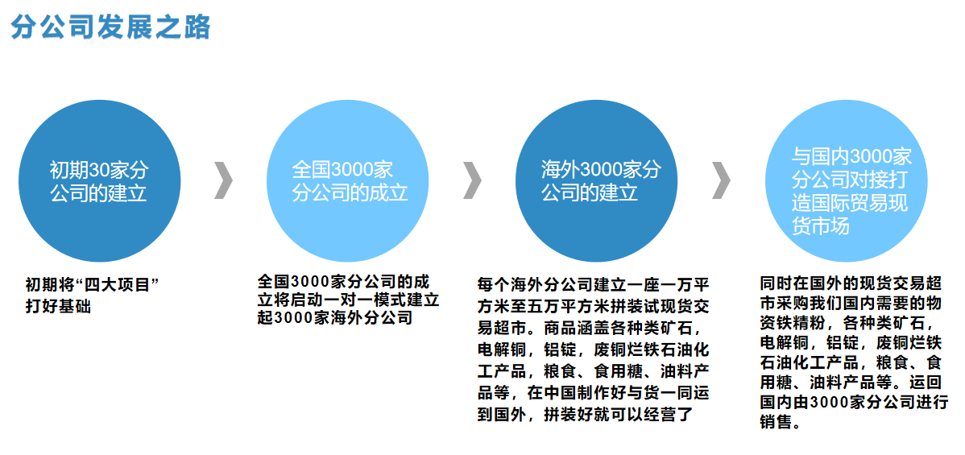

**4.1外贸平台预算及建设计划**

**4.1 foreign trade platform budget and construction plan**

**资金投入:50-80万**

**投入地点:北京**

**出口地点:俄罗斯 欧洲**

**公司部门建设:营业部、产品部、企划部、财务部。**

**初期投入费用:租金15万-20万(办公厅约150-200平米)**

**装修:2万-5万**

**办公使用物品3万-6万(含展厅展柜)**

**公司注册费用:5万**

**周转资金:15万-20万**

**Capital investment: 500000-800000**

**Place of investment: Beijing**

**Export location: Russia Europe**

**Department construction of the company: business department, product department, planning department and finance department.**

**Initial investment cost: rent 150000-200000 (about 150-200 square meters of the general office)**

**Decoration: 20000-50000**

**30000-60000 office items (including Exhibition cabinets in the exhibition hall)**

**Company registration fee: 50000**

**Working capital: 150000-200000**

**4.2外贸平台的建设**

**4.2 construction of foreign trade platform**

**外贸平台的建设涉及以下领域:**

**The construction of foreign trade platform involves the following fields:**

**4.2.1行政机关的注册、登记。包括工商、税务、海关、外汇局、商检局完成相关手续的办理;整个流程办理结束大概2个月时间。**

**4.2.1 registration and registration of administrative organs. Including the completion of relevant formalities by the administration of industry and commerce, taxation, customs, foreign exchange and commodity inspection; The whole process will take about 2 months.**

**4.2.2外贸部门的组建。外贸部门作为一个团队，由于分工不同，一般由业务员，财会(负责核销、退税)、单证员，质检员组成。人员的数量依据业务量而定;在公司创业初期，由于业务量不大，可以一人多职，如业务员可以负责单证的处理。**

**4.2.2 establishment of foreign trade department. As a team, due to different division of labor, the foreign trade department is generally composed of salesman, finance and accounting (responsible for verification and tax refund), document clerk and quality inspector. The number of personnel depends on the business volume; In the initial stage of the company, due to the small business volume, one person can have multiple duties. For example, the salesman can be responsible for the processing of documents.**

**4.2.3货运代理，快递公司的选择、确定。从实际操作看，目前大多数外贸公司的相关业务都是委托中介公司来完成的，如货物的进出口报关，商品法定检验及办理货物运输保险，可以省时省事。但选择合适的中介公司对外贸公司非常重要;好的中介公司可以促进外贸业务的发展。选择中介公司基本要求应该是业务熟练，专业知识强，服务效率高，收费合理。由于外贸公司的日常邮件多，费用较大，选择合适的国际快递公司可以有效节约费用。通过对全球主要快递公司的考察，UPS收费相对便宜(可以打折到73%)，时间上也比较快，一般在2-3个工作日可以到达全球各地。唯一的缺点是货物的重量 由UPS在事后帐单中告之。**

**4.2.3 selection and determination of freight forwarders and express companies. From the practical point of view, at present, most foreign trade companies entrust intermediary companies to complete their relevant businesses, such as import and export declaration of goods, legal inspection of goods and handling cargo transportation insurance, which can save time and trouble. However, it is very important for foreign trade companies to choose appropriate intermediary companies; A good intermediary company can promote the development of foreign trade business. The basic requirements for choosing an intermediary company should be proficient in business, strong professional knowledge, high service efficiency and reasonable charges. Due to the large amount of daily mail and high cost of foreign trade companies, choosing an appropriate international express company can effectively save costs. Through the investigation of the world's major express companies, UPS charges are relatively cheap (can be discounted to 73%), and the time is relatively fast. Generally, it can reach all parts of the world in 2-3 working days. The only disadvantage is that the weight of the goods is reported by UPS in the bill afterwards.**

**4.2.4公司形象的建立，如网站，产品规格、样品陈列公司形象是开拓外贸业务时公司的“名片”，外商往往是通过企业形象来逐渐了解其未来合作伙伴的。一个有实力，让外商感觉可信赖的公司，不仅可以加快合作的进程，而且也有利于将来业务量的不断拓展。如何建设公司外贸形象，可以由委托专业的网络公司、广告公司按照客户的旨意进行设计、策划，当然公司外贸形象的建设，也是逐步发展，不断完善的，不可能一步到位。**

**4.2.4 establishment of company image, such as website, product specifications and sample display. The company image is the "business card" of the company when developing foreign trade business. Foreign businessmen often gradually understand their future partners through the corporate image. A strong company that makes foreign investors feel reliable can not only speed up the process of cooperation, but also help to continuously expand business in the future. How to build the company's foreign trade image can be designed and planned by professional network companies and advertising companies according to the will of customers. Of course, the construction of the company's foreign trade image is also gradually developed and continuously improved, which can not be achieved in one step.**

**4.2.5参加外贸行业协会，成为会员。上海市外贸行业协会现有会员在5000家企业左右(包括浦东新区外贸协会)，外贸协会的主要功能为企业提供市场最新动态，邀请相关主管部门，如海关、税务、商检、外汇局主管领导为企业进行培训、讲座，内容涉及国家最新外贸政策变化以及进出口操作实际注意事项等。由于外贸协会和政府的关系密切，在企业遭受困难，由协会出面，有利于困难顺利解决;另外，随着国际贸易争端纷起，反倾销案件的增多，在外贸协会的组织下的积极应诉，据统计获胜的案件很多。**

**4.2.5 join the foreign trade industry association and become a member. At present, Shanghai Foreign Trade Association has about 5000 members (including the foreign trade association of Pudong New Area). The main function of the foreign trade association is to provide enterprises with the latest market trends, and invite the competent leaders of relevant competent departments, such as Haiguan, taxation, commodity inspection and foreign exchange bureau, to give training and lectures for enterprises, The content involves the latest changes in national foreign trade policies and practical precautions for import and export operation. Due to the close relationship between the foreign trade association and the government, if the enterprise suffers difficulties, the association will come forward, which is conducive to the smooth resolution of the difficulties; In addition, with the international trade disputes and the increase of anti-dumping cases, there are many successful cases under the organization of the foreign trade association.**

**4.3公司部门作用**

**4.3 role of the company's departments**

**4.3.1营业部:主要负责外交及接单接待、销售、业绩等。**

**4.3.1 business department: mainly responsible for diplomatic and order receiving reception, sales, performance, etc.**

**4.3.2产品部:主要负责产品管理及下单生产、寻找供应商交接沟通、临时调配主要配合营运部运作。**

**4.3.2 product department: mainly responsible for product management and order production, looking for suppliers, handover communication and temporary deployment, and mainly cooperate with the operation Department.**

**4.3.3财务部:主要负责款项来往管控及催款、劳务报酬核算公司财务管理。**

**4.3.3 finance department: mainly responsible for the control of cash flow, Dunning and labor remuneration accounting, and the company's financial management.**

**4.4运营模式及核算**

**4.4 operation mode and accounting**

**投资股份比例为100%，其中股东占3位，每人股份分配为30%，其中10%为外商业绩奖励股，不授权股份，只做核算使用。**

**The proportion of investment shares is 100%, of which 3 are shareholders, and the share distribution per person is 30%, of which 10% are foreign business performance award shares, which are not authorized shares and are only used for accounting.**

**股份倍增折算:股份倍增10倍。10X100%=1000%，每人占300%，其中100%为外商业奖励股。 其奖励方式如下:**

**Conversion of share multiplication: 10 times of share multiplication. 10x100% = 1000%, accounting for 300% per person, of which 100% are foreign business incentive shares. The rewards are as follows:**

**累积倍增方式:你接单8万 开发A、B、C、D外商。其他A、B、C、D每人接单8万， 8X5=40万，你的利润:40万X0.9%=3万6千-[ABCDX0.3=2400]X4=9600 3万6千-9600=26400是你真正的利润。加0.2%分红=你的股份收入**

**公司利润占比 3%基本收入+5%人员提成+2%分红预算=毛利**

**净利=毛利-提成-公司费用**

**如:借外力合作无达到预期工作，请见公司职员运营明细方案。**

**Cumulative multiplication method: you receive an order of 80000 to develop foreign investors a, B, C and D. Other a, B, C and D each receive 80000 orders, 8x5 = 400000, your profit: 400000 x0.9% = 36000 - [abcdx0.3 = 2400] X4 = 960036000 - 9600 = 26400 is your real profit. Plus 0.2% dividend = your share income**

**The company's profit accounts for 3% of basic income + 5% of personnel commission + 2% of dividend budget = gross profit**

**Net profit = gross profit - Commission - company expenses**

**For example, if the cooperation with external forces fails to achieve the expected work, please refer to the detailed operation plan of the company's employees.**

**4.5公司销售产品**

**4.5 products sold by the company**

**出口产品:国内需要的物资铁精粉，各种类矿石，电解铜，铝锭，废铜烂铁石油化工产品，粮食、食用糖、油料产品等。**

**Export products: domestic materials, refined iron powder, various ores, electrolytic copper, aluminum ingots, scrap iron, petrochemical products, grain, edible sugar, oil products, etc.**

**4.6出口流程**

**4.6 export process**

**报价、订货、付款方式、备货、包装、通关手续、装船、运输保险、提单、结汇。**

**Quotation, order, payment method, goods preparation, packaging, customs clearance procedures, shipment, transportation insurance, bill of lading and foreign exchange settlement.**